**CURRICULUM VITAE**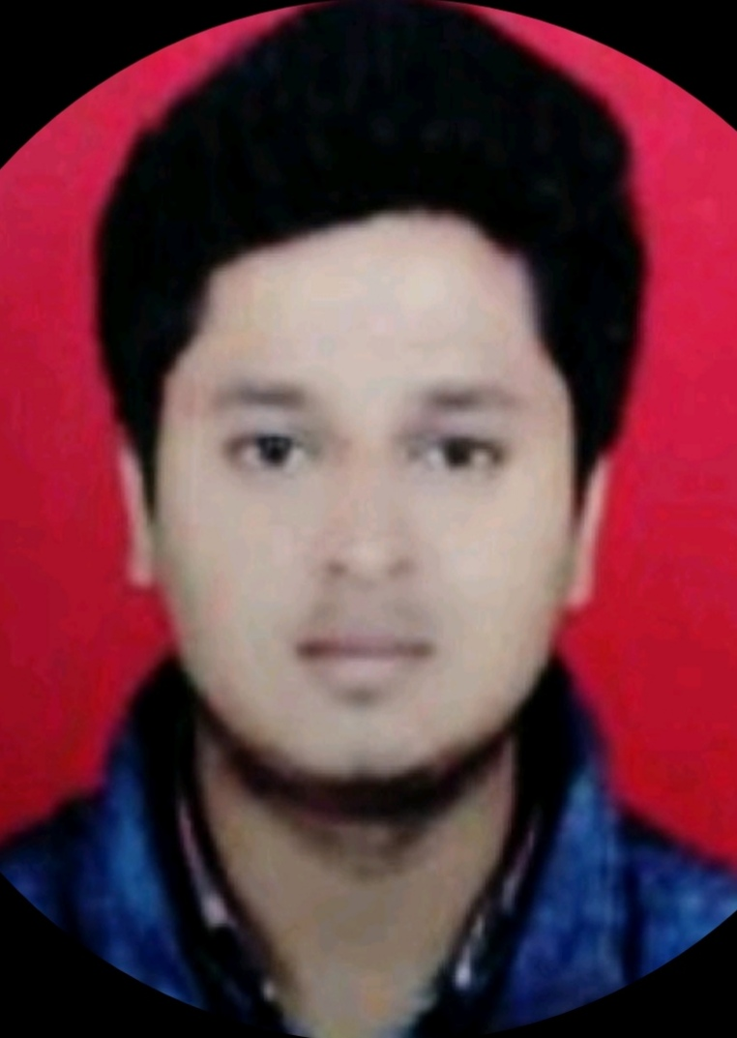

**SHAIKH TAHER LATIF,**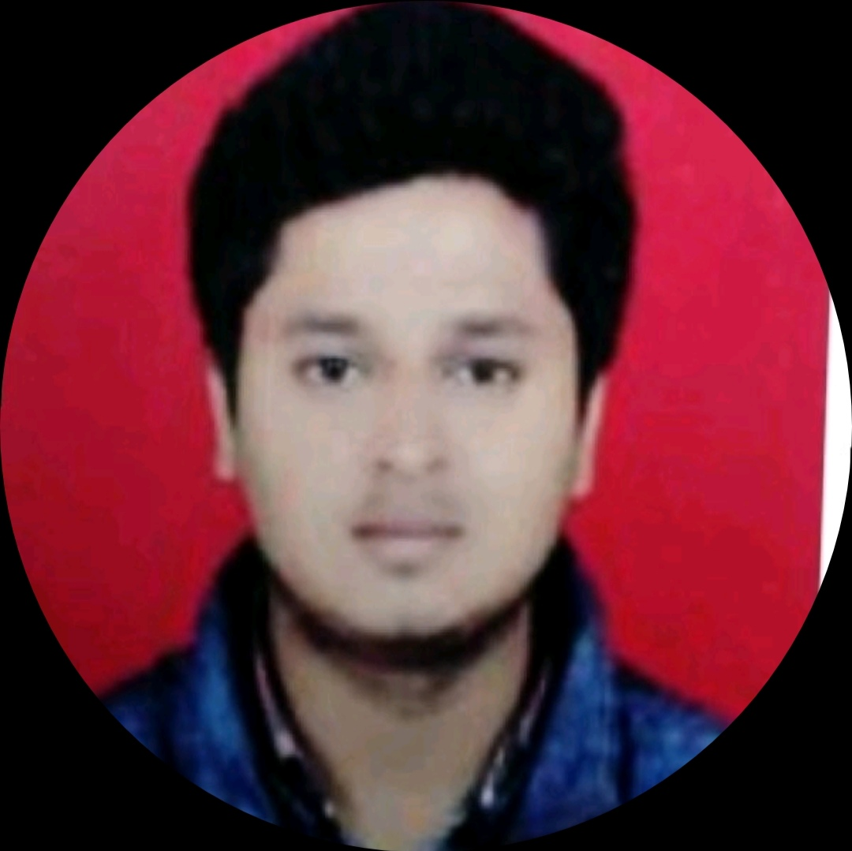

**S.B.Vihar, Plot no. 36,**

**Mantri Chandak,**

**Hotagi Road,Solapur**

**Solapur – 413004**

**E-Mail ID –** [Tahershaikh624@](mailto:barbadedhanraj@gmail.com)**[gmail.com](mailto:barbadedhanraj@gmail.com)**

* **CAREER OBJECTIVES**

Attain Responsible position in growth-oriented organization where I can

develop my capability and achieve self-actualization and contribute productively

to the Organization.

* **ACADEMIC QUALIFICATION**

|  |  |  |  |  |
| --- | --- | --- | --- | --- |
| **Qualification** | **Name of the Institute** | **University/**  **board** | **Year** | **Percentage** |
| **B.E(Electrical)** | **G.H.Raisoni Institute of Engineering & Technology,**  **Pune** | **Pune University,Pune** | **2016-2017** | **50%** |
| **TE** | **2015-2016** | **50%** |
| **SE** | **2013-2014** | **45%** |
| **Diploma(TE)** | **VVP Polytechnic,**  **Solapur.** | **M.S.B.T.E** | **2012-2013** | **66%** |
| **SE** | **2011-2012** | **70%** |
| **FE** | **2010-2011** | **74%** |
| **SSC** | **Saint Joseph Convent School,Solapur.** | **Pune Board** | **2009-2010** | **73.09%** |

* **Academic Project**

1)**Intelligent Traffic Control System(B.EProject)**

**The main objective of this Study was to design and implement intelligent traffic control system.The System developed is able to sense the Presence Or Absence of Vehicles within A Certain range by setting the appropriate duration for the traffic signals to react accordingly.**

***2)* Meeting Hall Lighting Control (Diploma Project)**

**The main objective of this Project is to Save Electricity.The system is developed to Consume Electricity in Advanced & better way so that there will be Reliability & Efficiency in System.**

* **Certification**

**PLC & SCADA Programming training Course in Sachin Kadam institutes (9850432567),Pune**

* **Industrial training**

**Completed One week Industrial Training Workshop On Transformer training Design Manufacturing & Testing Conducted from 11th of january to 15th of January 2016 organized by Department of Electrical Engineering ,GHRIET,Wagholi,Pune in Collaboration with N.KENIN.TRANSFORMERS.**

* **Achievement**

**1)Inter Engineering Diploma Student's Association Maharashtra State Zonal Sport's( Zone C Winner).**

**2)Secured Winner Position in Basketball Tournament Antaragni @ G.H.Raisoni Institute.**

**3)Secured 2nd position in Basketball Tournament Antaragni @ G.H.Raisoni Institute.**

**4)Won 2 times Inter House Basketball Tournament .**

**5)Training Certification Of RSP Solapur Police 2007-2010.**

**Extra -Curricular Activities**

* Participated in All india Camel Colours Contest.
* Participated in A National Level Paper presentation & Paper Project.
* Participated in College Level Dance Competition.

**Experience:**

**1) Worked in "WNS Global organization" as BMS EXECUTIVE.**

**2) Worked in "Amar Transformer" as Electrical Supervisor.**

**3) Worked in Sunmitra Resources Solar Power, Solapur.**

**4) Worked in Atlas Copco as Logistics Supervisor.**

**4) Presently working in Beyond Billboards as SEO Executive & Performance Driven Marketer.**

**STRENGTH**

* Eager to learn anything new.
* Determined to take up challenging assignment, able to work in challenging condition.
* Positive and self-motivated.
* Creative and willing to assume increased responsibilities.
* Ability to work both as an effective team member and independently using own initiative.

**PERSONAL DETAILS:**

* Name :SHAIKH TAHER LATIF.
* Date of Birth : 7th November, 1994.
* Sex : Male
* Phone number :+91 9325584603.
* Language known : English, Hindi, Marathi.
* Marital Status : Single
* Interest hobbies : Playing Football and Cricket, Listening to Music, Loves Dancingetc.
* Web Presence : https://www.linkedin.com/taher-shaikh-5387879a
* Date :
* Place :

SHAIKH TAHER LATIF